***Error while creating exe of Display app***

***Pyinstaller (create exe of python files) works out-of-the-box with any Python version 2.7 / 3.5 - 3.7 and PyGI (***Cross-platform python dynamic bindings of GObject-based libraries***) 3.24.1 AIO rev1 for python 2.7, 3.1, 3.2, 3.3 and 3.4 (32bit/64bit). Here is the challenge for creating executable file for it, so to run this we have to do configuration.***

***In python 2.7 scripts package (which contains pip, pip2, easy_install…) is not available for download pyinstaller to make exe of code.***

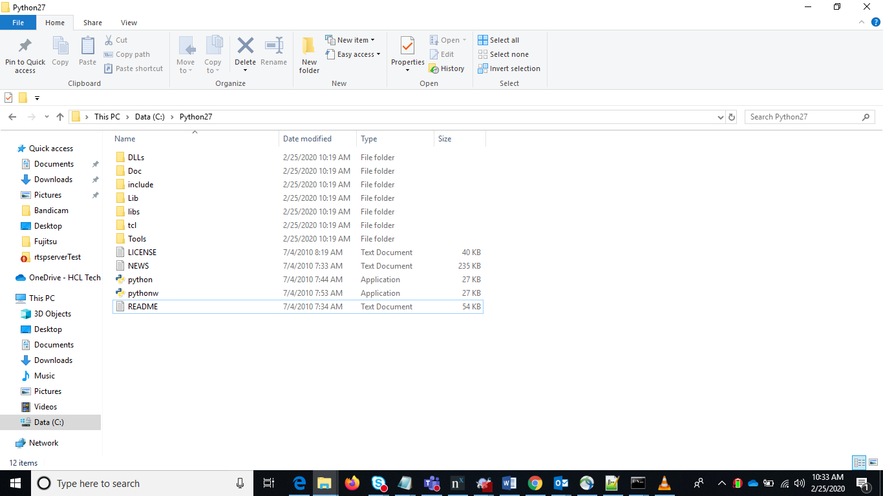

***Configuration steps***

***Installation of Gst 1.0 and Python modules***

* ***Install GStreamer 1.0 from*** [***https://gstreamer.freedesktop.org/download***](https://gstreamer.freedesktop.org/download) ***and Check environment:  
    
  GSTREAMER_1_0_ROOT_X86 = Gst 1.0 installation dir  
    
  GST_PLUGIN_PATH_1_0 = %GSTREAMER_1_0_ROOT_X86%\lib\gstreamer-1.0\  
    
  Path=%GSTREAMER_1_0_ROOT_X86%\bin;%GSTREAMER_1_0_ROOT_X86%\lib;%Path%***
* ***Step 1: Download and Install Python 2.X.X or 3.x.x – 3.4 .***
* ***Wget for download python using terminal. I have attached wget in zip file, install and put into C:\Windows\System32\ folder.***
* *C:\>wget* [*https://www.python.org/ftp/python/2.7.9/python-2.7.9.amd64.msi*](https://www.python.org/ftp/python/2.7.9/python-2.7.9.amd64.msi) *// for download*
* *C:\>/python-2.7.9.amd64.msi //for installation*
* *Set environment variable of python path =* *C:\Python27*

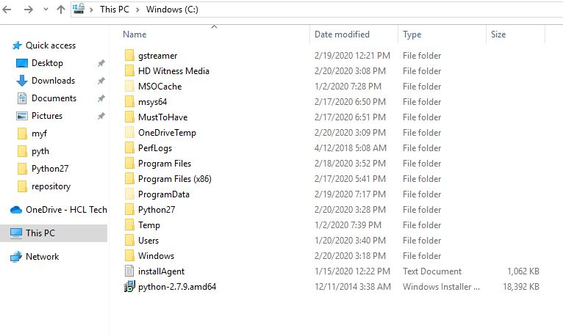

* ***download pygi-aio-3.10.2-win32_rev14-setup from*** [***https://sourceforge.net/projects/pygobjectwin32/files/***](https://sourceforge.net/projects/pygobjectwin32/files/) ***.***
* ***Install pygi-aio where it is downloaded.***
* ***Include Gstreamer and plugins in the installation.***

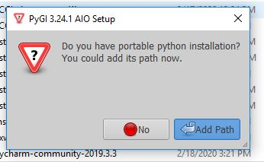

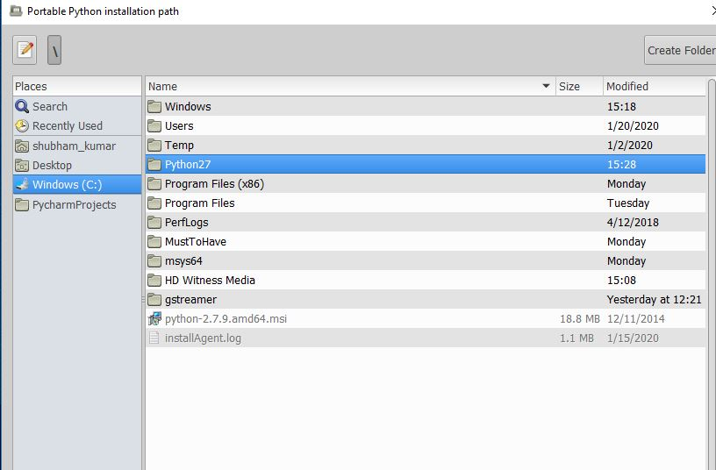

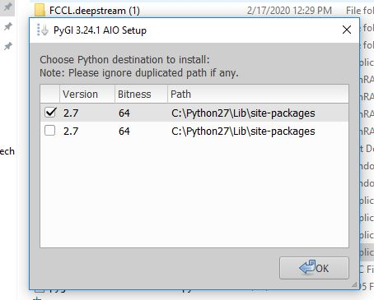

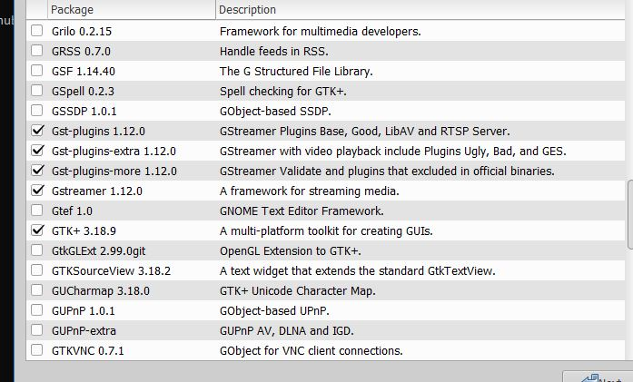

Select base packages also on top

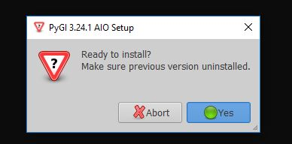

* ***Create file gi.pth at location C:\Python27\Lib\site-packages\ which file will contain gstreamer environment variable.***

***Like this  
  
%GSTREAMER_1_0_ROOT_X86%\bin  
  
%GSTREAMER_1_0_ROOT_X86%\lib***

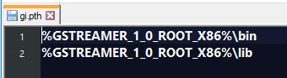

* ***Run the python file final_disp.py through command line.***